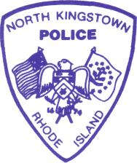
NORTH KINGSTOWN POLICE DEPARTMENT
8166 POST ROAD, NORTH KINGSTOWN, RHODE ISLAND 02852
Telephone: (401) 294-3311 FAX: (401) 294-6830
Administrative Offices: (401) 294-3316

CHIEF OF POLICE
Patrick Flanagan

PRESS RELEASE

MISSING PERSON

Michael Sinotte Jr. of North Kingstown was last seen on June 14, 2019 at 2:04 a.m. in the area of the West Kingston Post Office, 3484 Kingstown Rd, West Kingston, RI.

On June 17, 2019 Mr. Sinotte’s vehicle, a 2000 black Honda Civic displaying Rhode Island registration DW-583 was located in the area of the Great Swamp Management Area in West Kingston, RI.

Mr. Sinotte is described as; white, male, 22 years old, 5’ 11”, thin build, brown eyes, and sandy hair.

If you have seen Michael Sinotte Jr. or know of his whereabouts, please contact the North Kingstown Police Department Detective Division at (401) 294-3316 extension 8211.



For Immediate Release, July 1, 2019
________________________
Lieutenant Jeffrey St. Onge
Detective Commander

